Experiment #6 – Frequency Modulation

# Youssef Samwel

# [yo800238@ucf.edu](mailto:yo800238@ucf.edu)

# EEE3352 Signal Analysis and Analog Communications

Prof. Dr. Masoumeh Kalantari-Khandani - Section 0012

# 10/31/2023 – 11/7/2023



# **Project Description**

The objective of this experiment is to introduce and explain FM modulation and different types of modulations to students.

# **2.0 About Laboratory Day and Equipment List**

# The laboratory session took place on the Tuesday section between 8:00am and 11:00am on October 31 and November 7, 2023. My lab partners were Joahn. The equipment for the is experiment is listed below,

1. USB Flash Drive
2. Rohde & Schwarz RTM 3034 Oscilloscope
3. Tektronix AFG3022 Function Generator
4. XR2206 VCO
5. LM565 PLL

# **3.0 Pre-Laboratory Preparation**

# 3.2 Questions

1) Provide a paragraph, where you compare AM and FM modulation (advantages, disadvantages).

AM (Amplitude Modulation) involves shifting the frequency of the message signal to the baseband frequency. This modulation method, compared to others, is notably simpler and facilitates a broad transmission range. However, AM signals are highly susceptible to interference due to their inherent nature. In contrast, FM (Frequency Modulation) exhibits a reduced vulnerability to interference, ensuring greater signal integrity and, particularly in audio applications, improved sound quality. Nonetheless, FM's advantage comes with the trade-off of increased complexity and higher bandwidth usage, necessitating more sophisticated equipment and, consequently, higher costs.

2) Why is the use of FM more preferred than PM? Explain your answer. (Hint: Compare the frequency deviations in both cases)

In FM, information is encoded through alterations in the frequency of the carrier signal, while PM utilizes variations in the phase for encoding. FM signals allow for more precise and efficient detection and correction of frequency deviations compared to phase variations in PM. One significant reason for the preference for FM lies in the simplicity of determining the bandwidth of an FM signal using Carson’s formula rule, while the process is notably more complex for PM signals. PM requires the transmitter to compute the derivative of the signal and the receiver to integrate the received message, adding substantial complexity and latency to the system. Additionally, controlling frequency deviations is notably more manageable than controlling phase deviations, and they exhibit greater resilience against interference and noise.

3) Give a short qualitative justification of the fact that FM has more noise immunity than AM.

FM showcases superior noise immunity compared to AM due to the inherent features of their modulation techniques. In AM, the information is represented by the amplitude of the carrier wave, making it susceptible to variations or disturbances in amplitude that can mistakenly alter the encoded information, leading to vulnerability to noise. In contrast, FM encodes information within frequency variations while maintaining a consistent amplitude. As the information is conveyed through frequency changes, noise impacting the signal's amplitude is less likely to distort the encoded information, resulting in FM exhibiting enhanced noise immunity when compared to AM.

# 3.4 Simulation

Simulink Flow path

Input Signal

Modulated Signal

Demodulated Signal

# **4.0 Experimental Procedure**

a. Build the FM modulator shown in Fig. 6.5 (a).

b. Determine the constant kf from the following:

(1) Use your triple output power supply to apply the input voltages specified in the following table and record the output frequency: (Take screen shots for the modulated signal with its frequency measurement) Adjust the best signal sketch by using the scale knob. You can also use an adequate timebase value.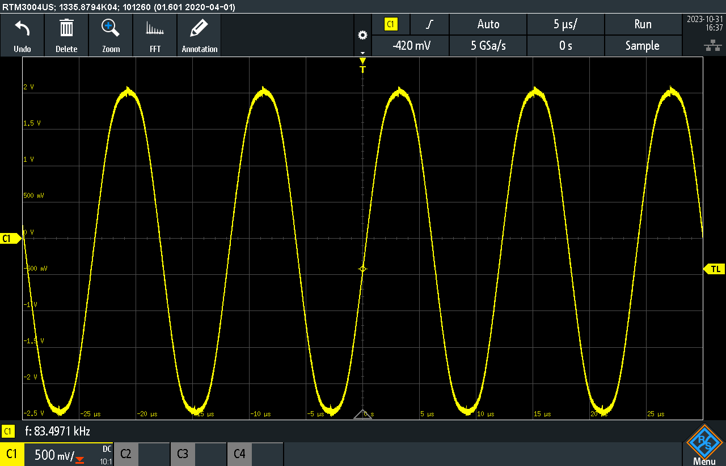

when

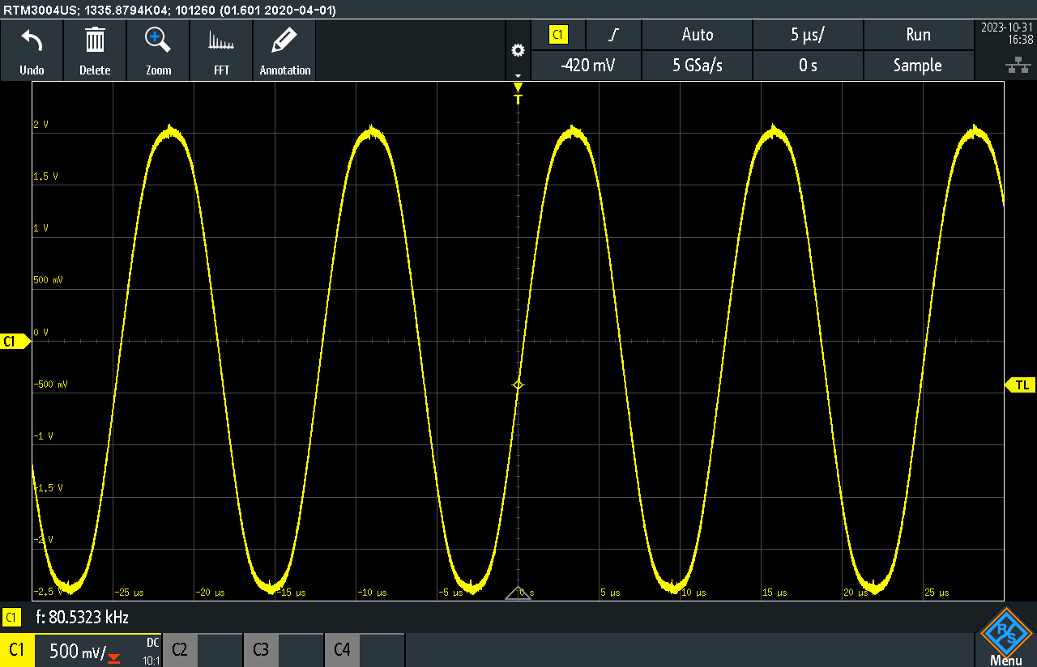

when

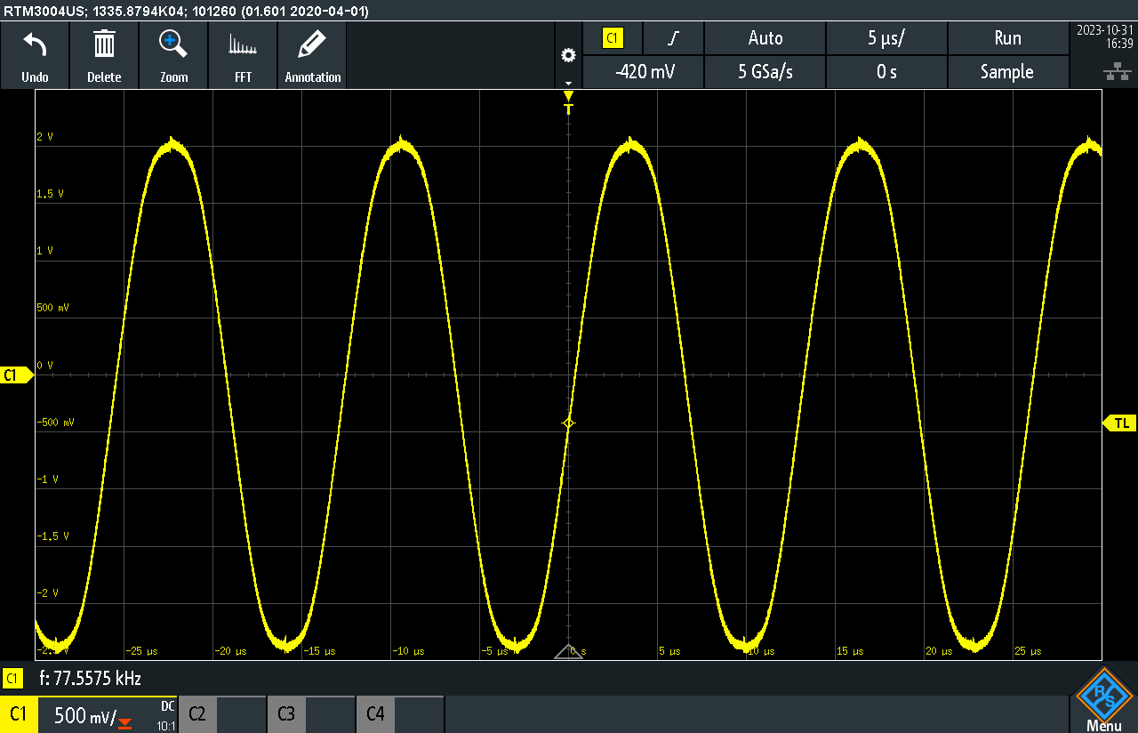

when

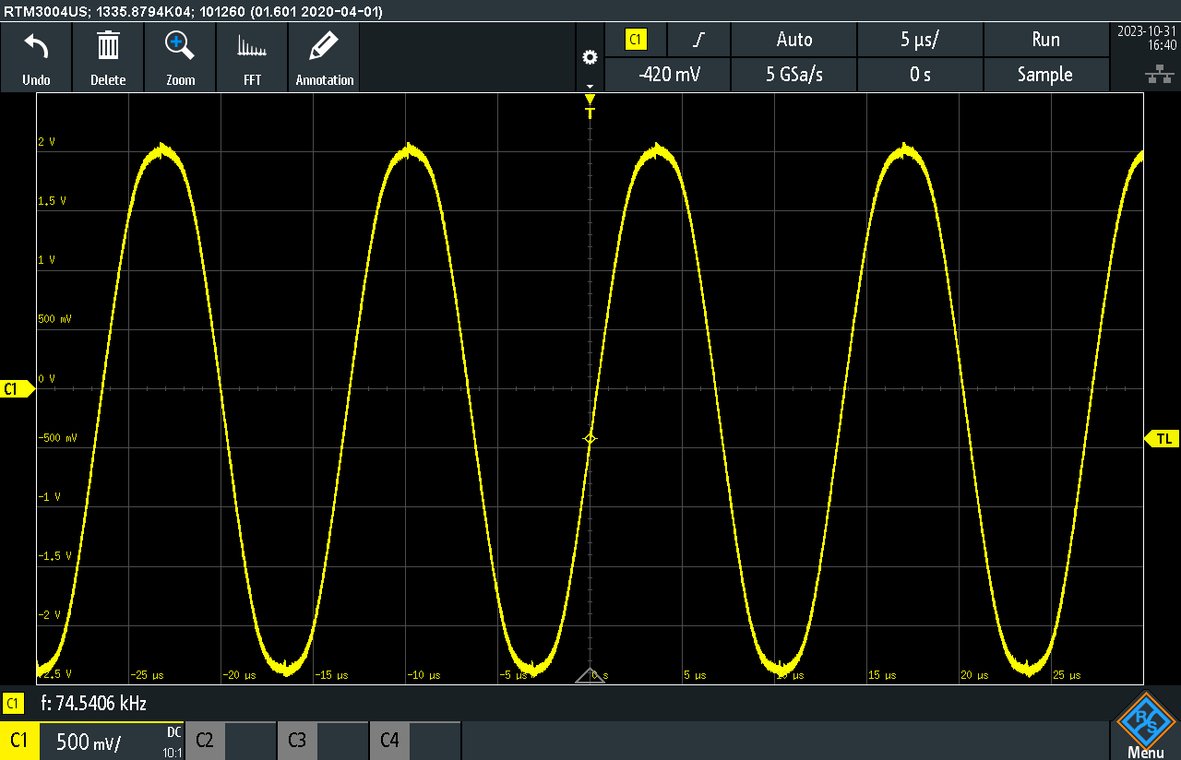

when

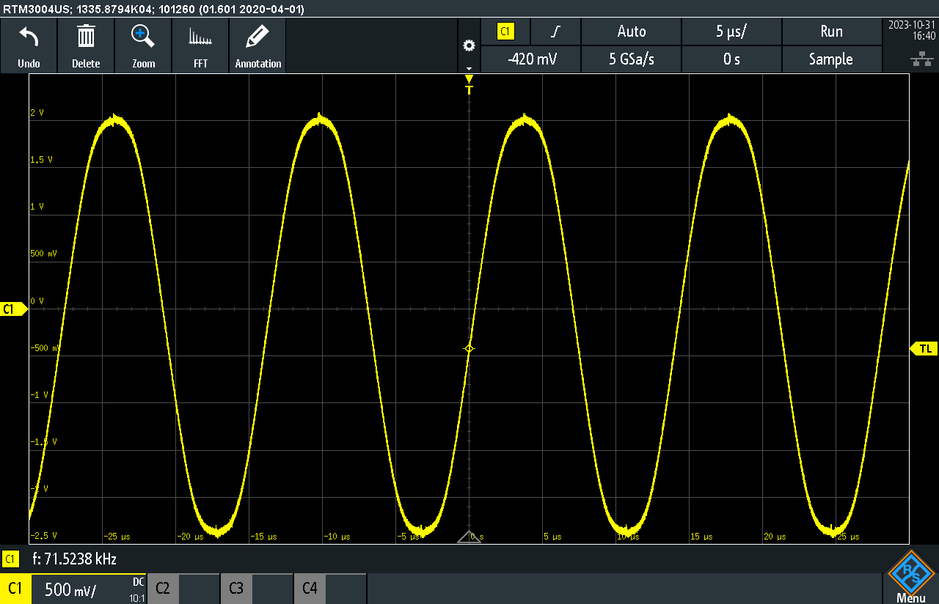

when

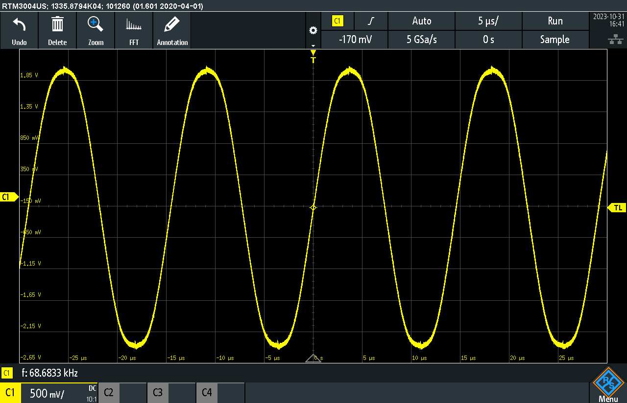

when

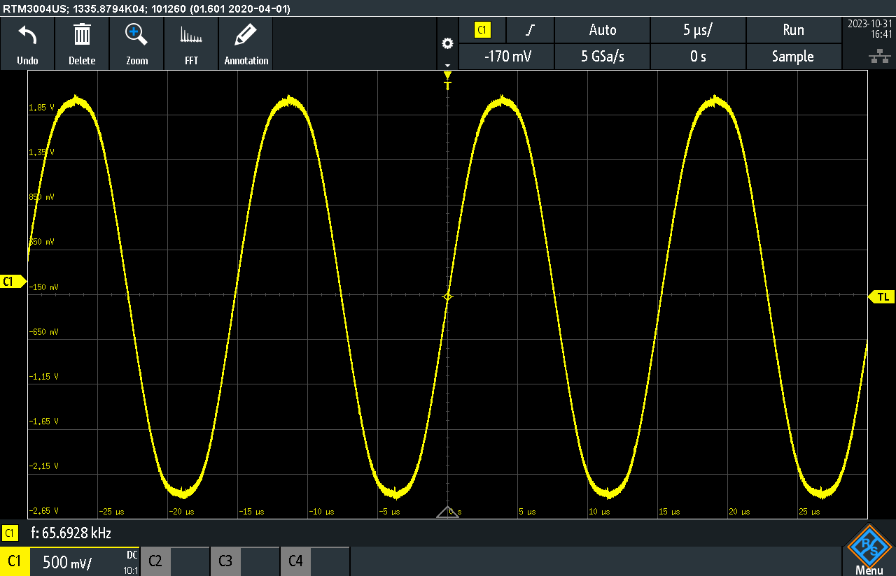

when

|  |  |
| --- | --- |
| (Volts) | (KHz) |
| 0.0 | 83.5 KHz |
| +1.0 | 80.3 KHz |
| +2.0 | 77.6 KHz |
| +3.0 | 74.5 KHz |
| +4.0 | 71.5 KHz |
| +5.0 | 68.7 KHz |
| +6.0 | 65.6 KHz |

(2) Plot vs. . Draw the best straight line through these points. The slope of this line is . Note that has units of Hz/Volts. What is the measured value of ?

(3) According to the XR2206 data sheet, the expected voltage-to-frequency conversion gain is Hertz/Volts.

Calculate the expected value of . Assuming the resistors have a tolerance of ±10% and the capacitors have a tolerance of ±20%, how do the measured and calculated values compare?

The error of formula is, . Given the tolerances of the components used, this is actually a very small error for such a simple function.

c. Add input coupling capacitor C2 to the circuit as shown in Fig. 6.5 (b). Set the modulation frequency to = 2KHz. Fill in the following table using the following equations: (Take screen shots for the modulated signal with its frequency measurement) Adjust the best signal sketch by using the scale knob. You can also use an adequate timebase value.

|  |  |  |  |
| --- | --- | --- | --- |
| (modulation index) | Calculated (Hz) | Calculated | Measured (Hz) |
| 4.50 | 9000 | 2.8125 | 8686.644 |
| 5.25 | 10500 | 3.2812 | 9928.389 |
| 9.00 | 18000 | 5.6250 | 17106.549 |
| 10.5 | 21000 | 6.5625 | 19542.851 |
| 12.3 | 24600 | 7.6875 | 20768.158 |

d. Use the Vin found as the amplitude of the input signal and find ∆fpeak on the oscilloscope. Compare ∆fpeak calculated and measured. Display only the FM signal on the oscilloscope and trigger on the rising edge of the waveform such that you see the following Fig. 6.6 (it will look like a ribbon): This "ribbon" displays all frequencies in the FM signal at once. The minimum and maximum frequencies can be easily detected and directly measured. Recall that ∆fpeak is only half of the peek-to-peak frequency swing. What parameters determine the bandwidth of an FM signal?

The bandwidth of an FM signal is influenced by several key parameters. Primarily, it's determined by the deviation from the center frequency caused by the message signal. This shift in frequency, varying from the central carrier frequency, defines the range of frequencies transmitted and, consequently, the signal's bandwidth. To ascertain the bandwidth, it's essential to identify the lowest and highest frequencies resulting from the impact of the message signal. Additionally, the modulation constant, denoted as , plays a pivotal role in shaping the extent of frequency deviation. This constant governs how much the frequency deviates from the carrier signal, further affecting the overall bandwidth of the FM signal.

e. View the frequency domain waveform to obtain modulation indices of 2.4, 5.52, 8.65. These are zero carrier amplitude indices. Include calculations to verify your results in your lab report.

# 4.5 Demodulation

Input Sine Wave (Yellow) vs Demodulated Signal (Green)

Input Square Wave (Yellow) vs Demodulated Signal (Green)

Input Triangle Wave (Yellow) vs Demodulated Signal (Green)

b. Apply a sinusoidal message signal and observe the demodulated message signal. Sketch both wave-forms. How do they compare?

The sine message signal passes through the modulation and demodulation with minimal distortion. The received function is mostly intact; however, it has some higher frequency noise (see screenshot) this is due to the properties of FM modulation.

c. Apply a square wave message signal and observe the demodulated message signal. Sketch both waveforms. How do they compare? Why is the demodulated sinusoidal message more faithfully reproduced than the demodulated square wave?

The output message is no longer a square wave. This is due to the fact that square waves have an infinite number of harmonic frequencies and therefore there wasn’t enough bandwidth to convey the square wave leading to distortion.

# 4.8 MATLAB Code

Used to generate figure(s).

close all

% kf dataset

Vin = [0, 1, 2, 3, 4, 5, 6];

Fout = [83.5, 80.3, 77.6, 74.5, 71.5, 68.7, 65.6];

curve_fit = polyfit(Vin,Fout,1);

f = figure;

f.Position = [50, 50, 960, 720];

plot(Vin, Fout, '.', 'MarkerSize', 15);

hold on;

title("VCO f_{out} (KHz) change with respect to V_{in}");

xlabel("V_{in} (Volts)");

ylabel("Output Frequency (KHz)");

% Annotating a specific X value point (for example, X = 3)

specific_X = 3;

specific_Y = Fout(Vin == specific_X); % Finding the corresponding Y value

text(3, 76.4, "k_f = " + curve_fit(1));

text(3, 77, "f(x) = " + curve_fit(1) + "x + " + curve_fit(2));

Fout_fit = curve_fit(1) .* Vin + curve_fit(2);

plot(Vin, Fout_fit, '--');

# **5.0 Learned Objectives**

* FM Modulation
* PM Modulation
* PLL Loop
* FM Demodulation
* VCO

# **6.0 Conclusion**

1. Explain a Phase-Locked Loop (PLL) system; discuss how it works.

The Phase-Locked Loop (PLL) operates by computing the difference of phase of the input signal with a reference signal, often the carrier signal, and then generates a voltage output signal that signifies the phase difference between the two signals. These output signals essentially encapsulate the message transmitted by the transmitter.

To ensure a smooth and stable signal, free from rapid changes and high-frequency noise, the output signal undergoes filtration via a low-pass filter. This filter reduces abrupt signal variations, providing an overall more stable signal that is more proportionally representative of the phase difference.

The filtered signal is subsequently fed back into the Voltage-Controlled Oscillator (VCO) to produce generates another reference signal whose frequency is directly proportional to the previous input signal frequency.

This new reference signal from the VCO is then looped back to the phase detector, completing the feedback loop. As this loop operates, the phase difference between the input and output signals diminishes, and the VCO output frequency aligns with the input signal frequency.

2. Elaborate on Frequency Modulation (FM). Please write about 1 page explaining your understanding of FM and its parameters such as modulation index, modulation sensitivity (), and frequency deviation.

Frequency Modulation (FM) is a modulation technique where the frequency of a carrier signal varies based on the amplitude of the message signal, effectively encapsulating a message.

Commonly used in audio broadcasting, two-way radio communication, and signal processing, FM is characterized by parameters such as the modulation index (), representing the ratio of peak frequency deviation to the modulating signal frequency, and the modulation sensitivity (), indicating the relationship between maximum frequency deviation and modulating signal amplitude.

The maximum frequency deviation (∆f) refers to the carrier frequency's deviation during modulation. FM is less prone to noise compared to amplitude modulation (AM), making it ideal for high-fidelity audio transmission. The summary concludes by highlighting the experiment's effectiveness in providing a hands-on understanding of FM modulation, emphasizing its advantages over AM, and showcasing practical applications in telecommunications.

In conclusion, the experiment on Frequency Modulation (FM) offered a comprehensive understanding of FM modulation techniques and comparison with AM modulation. Through practical lab sessions, the distinctive characteristics of AM and FM, including their advantages and drawbacks, became evident. AM, characterized by simplicity and a broader transmission range, was contrasted with its susceptibility to interference, in stark contrast to FM's resilience against noise, offering superior signal integrity and sound quality, especially in audio applications. The preference for FM over PM was well-demonstrated, primarily due to FM's precise handling of frequency deviations, simplifying bandwidth determination through Carson’s formula rule. The experimentation process, including building the FM modulator and exploring parameters like modulation indices and bandwidth, provided hands-on experience, aligning theoretical knowledge with practical implementation. The role of modulation constants like in shaping frequency deviations and subsequently, the bandwidth of FM signals, was vividly highlighted. Overall, the experiment effectively conveyed the nuances and practical applications of FM modulation in telecommunications, enriching understanding in signal analysis and analog communications.